TOLU EUNICE

WORK SAMPLES
This is a collection of my work, which includes both academic projects and work from prior jobs. (that I have been given permission to share)

Contents
SECTION 1 (SOCIAL MEDIA ANALYTICS) 3
CHEF PII (FDA CRISIS) 3
PROGRAM EVALUATION FOR CARLETON UNIVERSITY 4
SOCIAL MEDIA PROJECT PROPOSAL 8
SECTION 2 DASHBOARDS AND DATA INFOGRAPHICS 14
PYTHON JUPYTER NOTEBOOK 19
Reading csv file for analysis: Fuel efficiency and air quality analysis for all countries. 19
#Python Program Password check 33

SECTION 1 (SOCIAL MEDIA ANALYTICS)

CHEF PII (FDA CRISIS)

CONTEXT
A Miami-based private chef named Chef Pii has faced criticism for her viral “pink sauce.” Chef pii posted a TikTok video last month, on June 11, 2022, of herself dipping a chicken nugget into a bowl of pink sauce. This video received over seven hundred and fifty thousand (750k) views. Chef Pii’s TikTok videos have received millions of views, with her most-watched video currently sitting at 6.7 million. Viewers have either been fascinated or appalled by the viral “pink sauce,” with many raising concerns about the product’s inconsistent quality control. She claims that the pink sauce contains oil from sunflower seeds, dragon fruit (the only ingredient that explains its bright colour), chilli pepper, garlic, and honey.
Since the products have not yet received FDA approval, there have been worries about the safety of the pink sauce since her products began shipping to customers in July. Concerns about the inconsistent nutritional data printed on each bottle sent to customers have also been raised. Since then, her business has ceased production while the product is “currently being officially tested in labs.” Chef Pii appeared in a recent live stream on July 25, 2022, just one month after her first popular video, to respond to several questions from her online audience. It did not go well because one inquired whether the sauce was FDA-approved (Food and Drug Administration). Chef Pii allegedly challenged the question, wondering what the customer meant by "FDA-approved". She went on to say that she does not sell medical products and that the Pink Sauce is not a medical product, implying that she has no idea what FDA approval is or what the agency does.¹

ANALYSIS

Link to Excel Dashboard(double click the Excel icon in edit mode):

ELEVATOR PITCH
Chef Pii appears to be on the right track. She has a positive attitude toward her fans and customers. She is willing to learn from mistakes (such as shutting down production and waiting for official

1
Bruce, L. Y. (2022, July 26). ‘F In FDA’ Trends After Questions About Pink Sauce Emerge on TikTok.
Retrieved from Forbes: https://www.forbes.com/sites/brucelee/2022/07/26/f-in-fda-trends- after-questions-about-pink-sauce-emerge-on-tiktok/?sh=5c6d03565f66

lab tests) and she promotes open communication. However, to regain her customers’ trust and reach new customers, she must hire professional help to manage her social media.

PROGRAM EVALUATION FOR CARLETON UNIVERSITY
Carleton University is a public, English-language research university located in Ottawa, Ontario, Canada. Carleton College was established in 1942. The provincial government founded Carleton as a university in 1952 through The Carleton University Act, which was revised in 1957, giving the institution its current name. Carleton continually seeks new ways to innovate in research, teaching, and learning. Carleton aspires to improve social decision-making and extend public understanding and dialogue to attain sustainable energy.
Carleton University has four strategic plans in place. The first is the Energy master plan, followed by the Transportation master plan, the Outdoor Space Master Plan, and the Campus Master Plan. Carleton’s primary aim is to accelerate the transition of energy resource use to a more sustainable energy future for Canada. Who isn’t surprised that their first strategic strategy is the Energy master plan? Carleton University’s environmental footprint will be reduced, utility operation costs will be shrunk, and reliability and safety will be increased, according to the energy master plan. Carleton is implementing its Transportation Plan with the assistance of the National Capital Commission (NCC). The Transportation Strategy’s principal purpose is to give recommendations that improve Choice, improvements to walking, biking, and transit, Safety; each mode is assigned space based on its vulnerability and Infrastructure; current Infrastructure should be maximized to support all ways. The plan’s long-term focus over the next five years will be strengthening campus transportation infrastructure, accessibility, and safety. The Outdoor Space Master Plan’s principal purpose is to assist Carleton in better planning and developing the campus’s outdoor spaces. Improvements are desired for campus walkways, paths, and trails to improve pedestrian and bicycle safety and access, current open spaces to make them more welcoming and multi-seasonal, and future open space initiatives to develop green space. The campus plan’s principal purpose is to comply with the University’s policy (The Strategic Integrated Plan (SIP)) of updating the Carleton University Campus Plan every five years.
Carleton has actors and stakeholders at all levels and across the broad area of Canada. External stakeholders include governments, private corporations, civil society groups, current students, alums, and parents. Internal stakeholders include students, faculty, and the Board of Directors. Government agencies are interested in reviewing the institutions’ annual financial records to ensure that the University follows Generally Accepted Accounting Principles (GAAP). Other external stakeholders are eager to participate and collaborate in achieving the University’s objectives. Students are willing to learn and communicate the value of a Carleton education to targeted groups. Staff and administrators have a strong interest in ensuring that students learn. The Board and management are concerned with the quality of the courses being offered, the resources, technology, and Infrastructure used to support the delivery of the courses, the academic staff who develop and conduct the classes, and the students who are accepted into the classes. Each educational stakeholder has a distinct role to perform. All parties, however, have a vested interest

in ensuring that students receive a good education. Good education builds a stronger community by educating children to be effective members of the community in the future. Securing stakeholder support is critical to the success of most organizational endeavors.

STAKEHOLDERS | METHOD OF GATHERING INFORMATION | USE OF INFORMATION
Government bodies and Board  - Canada Revenue Agency (CRA)  - Ministry of Training, Colleges, and Universities (MTCU)  - Financial lending institutions) | - Financial audit reports/feedback  - Roundtable discussions | - The feedback and report statement reflects stakeholder input and clarifies whether the standards align with the goals of Generally Accepted Accounting Principles (GAAP).  - If the school’s resources are well managed.
Private businesses and civil society organizations (CSOs) | - Semi-structured interviews  -CSO  - Roundtable discussions | - Investment opportunities-Private businesses.  - Mutual goal achievement-CSO’S
Alumni | - Alumni Events  - Alumni Ambassadors  - Voluntary help feedback | - Opportunity for mentoring younger students for career development.  - See any opportunity to help develop processes in achieving strategic plans.  - See any fundraising opportunity.
Student | - Student Ambassadors  - Course and professor evaluation assessments  - Student engagement in Social media | - Provide improvement on staff quality.  - Provide improvement of course and resource quality.  - Provide improvement on methods of achieving the strategic plan.
Staff | - Faculty and employee meeting | - Determine whether instructors are meeting educational standards.

POTENTIAL CONTROVERSY | WHY | KEY STAKEHOLDER
Funding delays | Ineligibility due to audit defaults | External: Government bodies, Private businesses, Alumni
Project Delays | Failing to meet key stakeholders’ expectations | External: Government bodies, Alumni, Private businesses.  Internal: Faculty/Staff
Corporate media crisis | Failing to meet key stakeholders’ expectations  Negative external perceptions of the project/institution | External: Alumni, Private businesses, Parents.  Internal: Students, Faculty/Staff

UNIVERSITY MISSION | USE OF INFORMATION
Innovation in research, teaching, and learning. | Research: Funding opportunities. (External stakeholders) Teaching: Feedback engagement from internal stakeholders. Learning: Continuous appreciation of internal stakeholders.
Increase public understanding, dialogue, and societal decision-making to attain sustainable energy. | Regular progress reports and early engagement with external stakeholders help establish accountability.  Positive media outlook.

CHANGE | IMPLICATION | STAKEHOLDERS TO INVOLVE | WHY STAKEHOLDERS NEED TO BE INVOLVED
Outdoor sports stadium. It will cost  $1.2m. | Increased spending More partnership opportunities Attracting potential students through social events | Government bodies [Ministry of Training, Colleges, and Universities (MTCU)], Private businesses, Alumni, Board | - Funding  - Assessment of viability of projects  - See to it that the project adheres to the directives of the University’s strategic plan.
Doubling the number of international students | A new set of stakeholders is introduced.  More financing is required to accommodate the new students. | Government bodies, boards, Alumni | - Fulfill legal and governmental requirements.  - Ensure diversity in representation.

Lowering the voluntary retirement age to 60 | Higher productivity because of younger employees.  Not everyone agrees with the concept. | Board, Faculty/Staff | - Board: Approving proposed regulations.  - Staff/Faculty: Examine the impact of the reform on those who have recently left or are still employed by the company.
Global COVID-19  pandemic | Project delays. Probable financial stress.  Possible reduction in enrollment.  Institutions fail to meet internal stakeholders’ expectations and are unsure how to address the situation. | Board, Faculty/Staff, Students, Government bodies, Health institutions | - Board, Government bodies -Ensure that policies favour significant internal stakeholders.  - Make sure to use the strategies that will improve learning and teaching.  - Health institutions: Ensure that all other campus participants follow safety procedures. While yet achieving the institution’s objectives.

SOCIAL MEDIA PROJECT PROPOSAL

Analyst company overview

- DataEco
Company
- Sudbury
- Canada
Service Area
- The Cambrian College Teaching and Learning Innovation Hub
Client
- Chief Data Analyst
- Support Data Analyst
- Contractors (Two social media design specialists)
Team


- The Cambrian College Teaching and Learning Innovation Hub (YouTube Channel)
Company
- Sudbury
- Canada
Service Area
- Cambrian College Students
- Research Collaborators
Client

The problem
The Cambrian College Teaching and Learning Innovation Hub (YouTube Channel)

Increased competition

Outdated YouTube content practices

Poor user experience
Improper video
organization

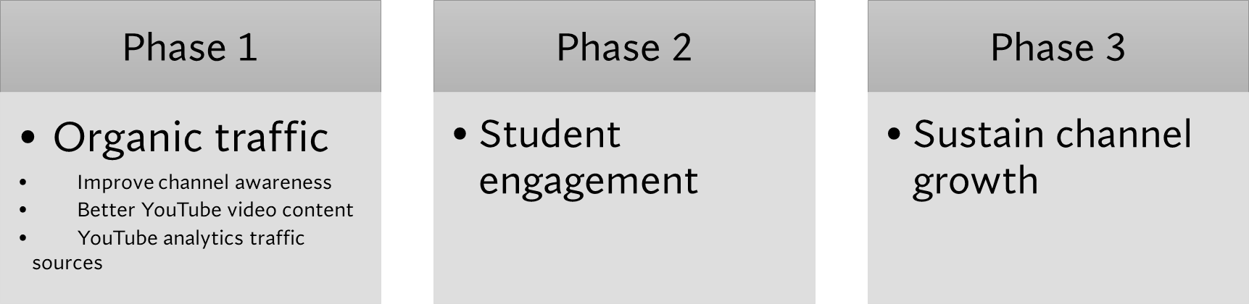
Project success roadmap


Project design and development 25%
Use of funds
Marketing Costs and risks 40%
Agents & Contractors 4%
Team salaries
12%
Operational Cost 19%
Marketing Costs and risks Operational Cost

Team salaries

Agents & Contractors Project design
and development

Figure 2: Pie chart showing financing for project

SECTION 2 DASHBOARDS AND DATA INFOGRAPHICS
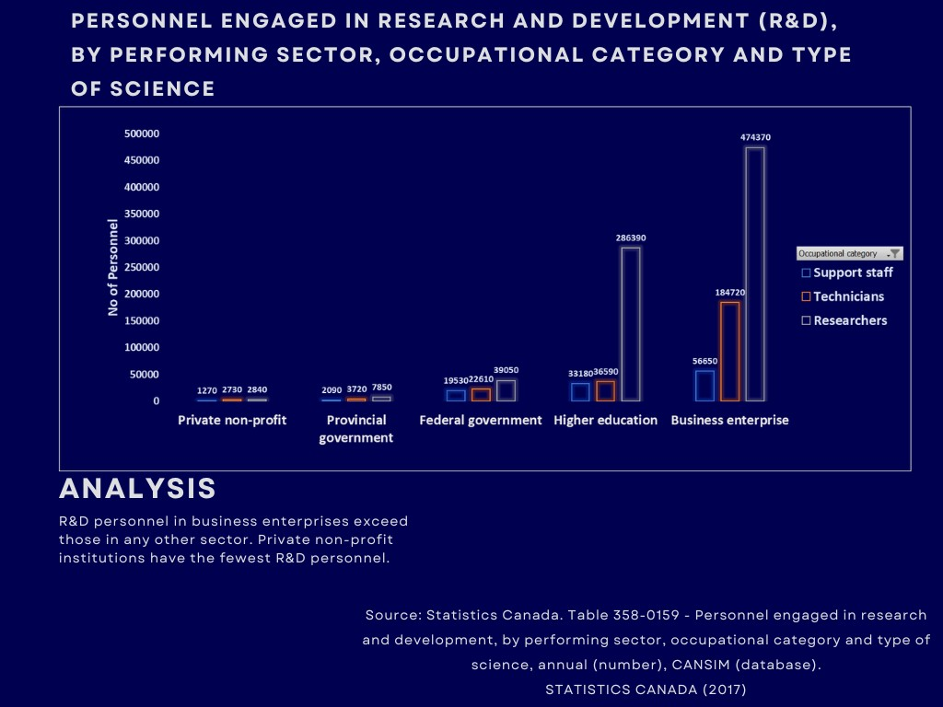

Figure 3: Data Infographic Sample 1

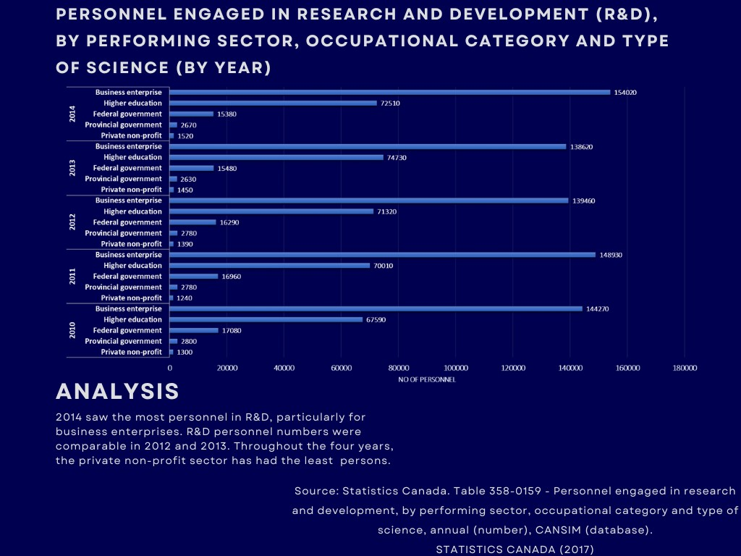

Figure 4: Data Infographic Sample 2
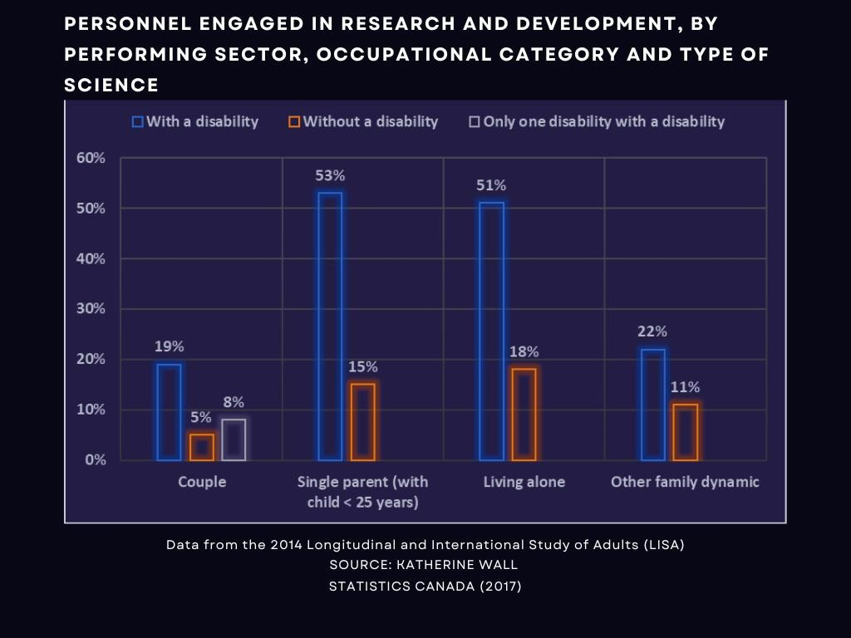

Figure 5: Data Infographic Sample 3
Economic Impact of Canadian Recreation Vehicle Industry

4000

3500

3000

2500
Sales (000,000's)

2000

1500

1000
RV Retail Sales
Economic Impact of Canadian Recreation Vehicle Industry

Tourism Expenditures
$4,957,232

Retail (excl. manufacturing)
$1,505,747
INDUSTRY

Non-Travel Expenditures
$1,317,606
Recreation Vehicle Dealers Association Consumer Survey (Age Breakdown)
Age 55 Age 35-54 Age 18-34

British Columbia
Alberta Manitoba/Saskatchewan
Ontario

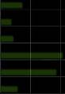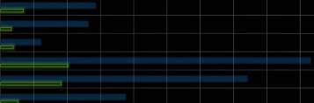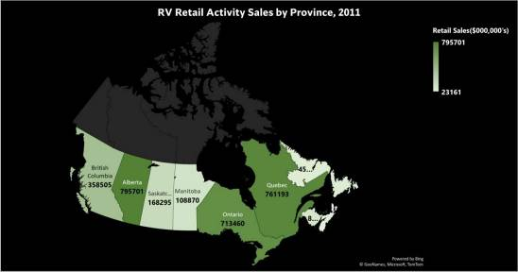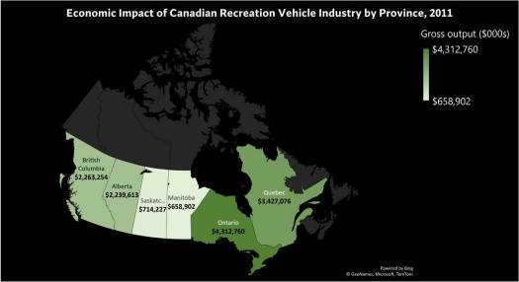
Apparent Domestic Market - Canada
2500
2000
1500
1000
500
0
2001
2002
2003
2004
2005
2006
2007
2008
2009
2010
500

0

2004 2005 2006 2007 2008 2009 2010 2011
Year

Manufacturing

$-

$210,046

$1,000,000 $2,000,000 $3,000,000 $4,000,000 $5,000,000 $6,000,000
GDP ($000’s)

Figure 6: Dashboard Sample 1
Québec Atlantic

0 50 100 150 200 250 300 350 400 450 500

Meals on Wheels Company Annual Report (2012 - 2020)

2012-2013
312

2013-2014

2014-2015

2015-2016
Year

2016-2017

2017-2018
380

2018-2019
366

2019-2020
418
Clients over 65

354

411

431

35000

30000

25000
Number of Hot Meals

20000

15000

10000

5000

0

30593
Hot meals Served (Hot meals program)
32706
30400 31396
28730 28783
323

30427

16784

500
450
400
350
Number of Cold meals
300
250
200
150
100
50
0

312 323
Cold meals Delivered

431
411

354

380 366

418

0 50 100 150 200 250 300 350 400 450 500
Number of Clients
2012-2013 2013-2014 2014-2015 2015-2016 2016-2017 2017-2018 2018-2019 2019-2020
Year
2012-2013 2013-2014 2014-2015 2015-2016 2016-2017 2017-2018 2018-2019 2019-2020
Year

140
Volunteers Involved

129

125

120
108

100
Number of Volunteers

80

89
79 82
Number of Volunteers

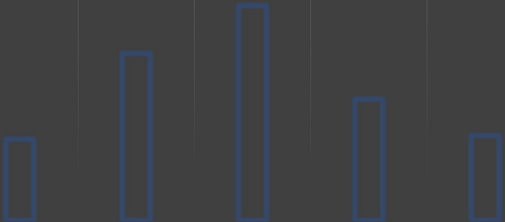
Volunteer Involved
5300
5209
5200

5100
5029
5000

4900
4858
4800
4707
4721
4700

4600

4500

4400
2013-2014
2014-2015
2015-2016
Year
2016-2017
2017-2018
60

40

20

0
2012-2013 2013-2014 2014-2015 2015-2016 2016-2017 2017-2018
Year

Dashboard Sample 1 Figure 7: Dashboard Sample 2

PYTHON JUPYTER NOTEBOOK

Reading csv file for analysis: Fuel efficiency and air quality analysis for all countries.

INTRODUCTION
Data is air quality index info for all countries from July 21st (07/21/22) - August 10th (08/10/22). Daily air quality is reported using the Air Quality Index (AQI). The AQI tells you how clean or filthy your air is and what health impacts you should be concerned about. The AQI is concerned with the health consequences of breathing dirty air within a few hours or days.
Index value status
Good: 0 – 50
Moderate: 51 -100
Unhealthy for Sensitive Groups: 101 – 150
Unhealthy: 151 - 200
Very Unhealthy: 201 - 300
Hazardous: >301
DATA SUMMARY
This is a time series analysis. Data was collected for 20 days. The number of countries analyzed was 142. The average value of the air quality index is 60.9. The standard deviation of the air quality index is 43.90. The minimum value is 1. The maximum value is 407. There are five countries with a minimum AQI value of “1”. These countries have a “good” AQI status. Guam, Cayman Islands, Venezuela, Grenada, and the Gambia are the countries. A noticeable trend for most countries on this list is small countries, mostly island territories. Guam is a US island territory in the Western Pacific; the Cayman Islands is a British island overseas territory. Grenada is an island country in the west indies in the Caribbean sea, Venezuela is on the upper north coast of South America with most Caribbean coast islands, and the Gambia is a small west African country with a narrow Atlantic coastline. Just one country had the maximum AQI value for these 20 days, Kuwait.
Using the histogram analysis confirms the right-skewed analysis of the boxplot. Most of the observations for the AQI lie to the right of the graph, making it a positively skewed histogram or a right-skewed histogram. The tail of the chart has lower frequencies/observations. One can say most countries have a good- moderate AQI value. Also, the Bar plot of AQI Count by Status shows that more countries were on the “Good” status. The “Moderate” status also had more countries than the “Hazardous” status group with the least number of countries. There are five countries on the Hazardous status level. These countries are Gabon, United Arab Emirates, Ethiopia, India, and Kuwait.

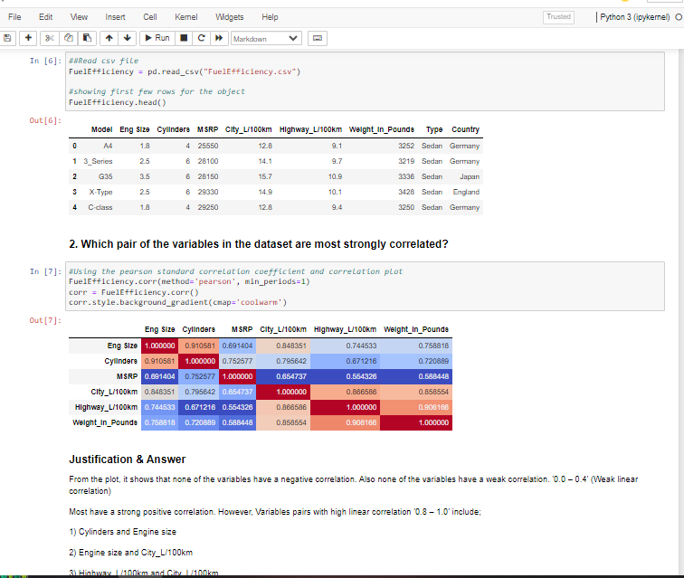

Import Python Libraries

In [152]: #Import Python Libraries
import numpy as np
import scipy as sp
import pandas as pd
import matplotlib.pyplot as plt import seaborn as sns
Reading csv file for analysis
In [153]: #Reading csv file for analysis
#air quality index data for all country from July 21st(07/21/22) - August 10th(08/10/22) air quality = pd.read csv("air quality.csv")
In [154]: #printing air quality data(just the first 10 few rows using ".head() method")
air_quality.head(10)
Out[154]: Date Country Status AQI Value
0 7/21/2022 Albania Good 14
1 7/21/2022 Algeria Moderate 65
2 7/21/2022 Andorra Moderate 55
3 7/21/2022 Angola Unhealthy for Sensitive Groups 113
4 7/21/2022 Argentina Moderate 63
5 7/21/2022 Armenia Moderate 76
6 7/21/2022 Australia Moderate 56
7 7/21/2022 Austria Good 45
8 7/21/2022 Azerbaijan Good 12
9 7/21/2022 Bahrain Unhealthy 165
In [155]: #Checking all data types for accuracy to allow for proper analysis
- As we can see the date colmn is of type object and we have to convert it to datetime format. air quality.info()
<class 'pandas.core.frame.DataFrame'> RangeIndex: 3668 entries, 0 to 3667 Data columns (total 4 columns):
- Column Non-Null Count Dtype
--- ------ -------------- -----
0 Date 3668 non-null object
1 Country 3668 non-null object
2 Status 3668 non-null object
3 AQI Value 3668 non-null int64 dtypes: int64(1), object(3)
memory usage: 114.8+ KB
In [156]: # we can use astype function
air_quality['Date'] = air_quality['Date'].astype('datetime64[ns]') air_quality.info() #checking the new data types
<class 'pandas.core.frame.DataFrame'> RangeIndex: 3668 entries, 0 to 3667
Data columns (total 4 columns):
- Column Non-Null Count Dtype
--- ------ -------------- -----
0 Date 3668 non-null datetime64[ns]
1 Country 3668 non-null object
2 Status 3668 non-null object
3 AQI Value 3668 non-null int64 dtypes: datetime64[ns](1), int64(1), object(2) memory usage: 114.8+ KB
Number of days data was collected
In [157]: #Time_difference from 07/21/22 - 08/10/22
date1=air_quality["Date"].min() date2=air quality["Date"].max()
In [158]: date2 - date1
Out[158]: Timedelta('20 days 00:00:00')
Data was collected for 20 days.
In [159]: #How many countries was the data collected for. #Using the unique method becuase most countries were repeated mul
len(air_quality['Country'].unique())
#142 countries
Out[159]: 142
Data Summary statistics
In [160]: air quality.describe() Out[160]: AQI Value
count 3668.000000
mean 60.928299
std 43.904289
min 1.000000
25% 29.000000
50% 53.000000
75% 82.000000
max 407.000000
Info on the countries with the minimum and maximum value
In [161]: #The countries with the minimum air quality index value is .
#From the summary statistics,it says the min value is 1 air_quality2= air_quality[air_quality["AQI Value"]== 1]
air quality2
Out[161]: Date Country Status AQI Value 53 2022-07-21 Guam Good 1
195 2022-07-21 Guam Good 1 478 2022-07-22 Guam Good 1 619 2022-07-22 Guam Good 1 731 2022-07-23 Cayman Islands Good 1 760 2022-07-23 Guam Good 1 901 2022-07-23 Guam Good 1 1042 2022-07-24 Guam Good 1 1183 2022-07-25 Guam Good 1 1295 2022-07-26 Cayman Islands Good 1 1324 2022-07-26 Guam Good 1 1436 2022-07-26 Cayman Islands Good 1 1606 2022-07-27 Guam Good 1 1747 2022-07-28 Guam Good 1 1859 2022-07-29 Cayman Islands Good 1 1888 2022-07-29 Guam Good 1 2000 2022-07-30 Cayman Islands Good 1 2029 2022-07-30 Guam Good 1 2170 2022-07-31 Guam Good 1 2452 2022-08-02 Guam Good 1 2734 2022-08-04 Guam Good 1 2960 2022-08-05 Venezuela Good 1 3128 2022-08-07 Cayman Islands Good 1 3155 2022-08-07 Grenada Good 1 3290 2022-08-08 Gambia Good 1
Date Country Status AQI Value 3439 2022-08-09 Guam Good 1 3580 2022-08-10 Guam Good 1
In [162]: #There seems to be a multiple countries for different days
#so this shows unique country items.
air quality2['Country'].unique()
Out[162]: array(['Guam', 'Cayman Islands', 'Venezuela', 'Grenada', 'Gambia'],
dtype=object)
In [163]: print("There are "+ str(len(air_quality2['Country'].unique())) + " countries with the minimum AQI values")
There are 5 countries with the minimum AQI values
In [164]: #The countries with the maximum air quality index value is .
#From the summary statistics,it says the min value is 407
air_quality3= air_quality[air_quality["AQI Value"]== 407]
air_quality3
Out[164]: Date Country Status AQI Value
3600 2022-08-10 Kuwait Hazardous 407
Just one country has the max AQI value for these 20 days and it was Kuwait.
Boxplot for the air quality index values
In [165]: air_quality.boxplot(column='AQI Value')
plt.show()
#A lot of outliers
#Right skewwed
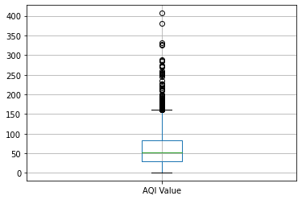
Histogram for the air quality index values
In [166]: #Use seaborn package to draw a histogram
sns.histplot(air quality['AQI Value']);
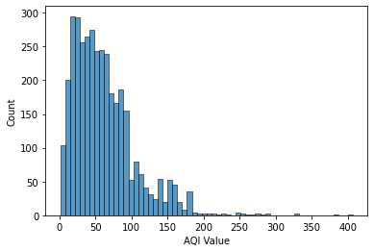
In [167]: sns.distplot(air quality['AQI Value']); #fill method to see skew outline
C:\Anaconda\lib\site-packages\seaborn\distributions.py:2619: FutureWarning: `distplot` is a deprecated function and will be removed in a future version. Please adapt your code to use either `displot` (a figure-level function with similar flexibility) or `histplot` (an axes-level function for histograms).
warnings.warn(msg, FutureWarning)
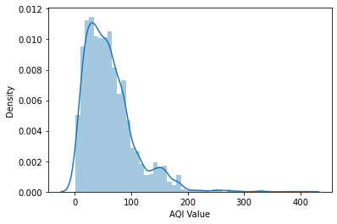
This confirms the right-skewwed analysis of the boxplot. Most of the observations for the AQI lies to the right of the graph which makes it a positively skewed histogram or a right-skewed histogram. The tail of the graph has lower frequencies/observations. One can say most countries have a good- moderate AQI value.
Barplot of AQI Count by Status
In [168]: plt.figure(figsize = (14,8))
ax = sns.barplot(x='Status',y ='AQI Value', data=air quality, estimator=len)
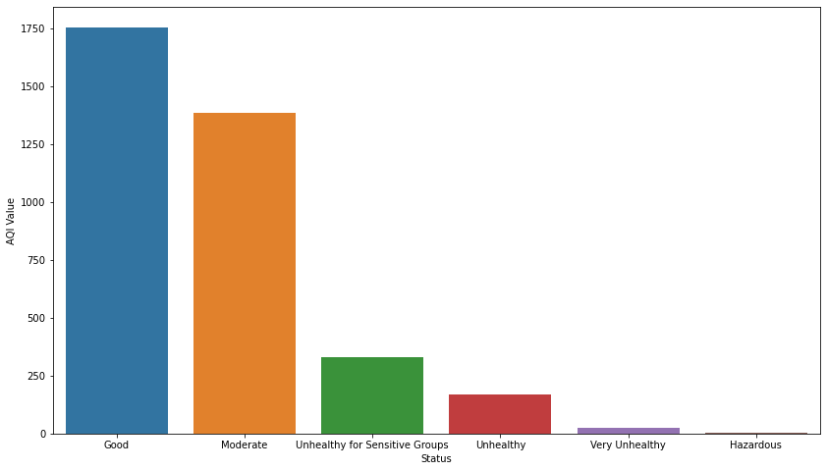
More countries were on the "Good" status. The "Moderate" status also had more countries compared to the "Hazardous" status group with the least number of countries.
Countries with Hazardous status
In [169]: # Countries with Hazardous status
air_quality4=air_quality[air_quality['Status'] == "Hazardous"] air quality4
Out[169]: Date Country Status AQI Value
892 2022-07-23 Gabon Hazardous 331
1545 2022-07-26 United Arab Emirates Hazardous 327
2016 2022-07-30 Ethiopia Hazardous 326
3304 2022-08-08 India Hazardous 380
3600 2022-08-10 Kuwait Hazardous 407
In [171]: air_quality4["Country"]
Out[171]: 892 Gabon 1545 United Arab Emirates
2016 Ethiopia 3304 India 3600 Kuwait Name: Country, dtype: object
There are five countries on the Hazardous status level. These countries are Gabon,United Arab Emirates,Ethiopia,India and Kuwait.

#Python Program Password check
1 import urllib.request
2 import json
3 import time
4 #Python Program Password check
5
6
7
8 print(" Keyword arguments (1234) ".center(60,"~"))
9 def checkPassword(user_pin):
10 range = 0
11 """Function with while loop and if statement to check if password entry is correct, password is passed as a keyword 12 argument"""
13 while True:
14 range += 1
15 user_input= int(input("Enter pin: "))
16 if user_pin == (user_input):
17 print("Unlocked!")
18 break
19 else:
20 print("Incorrect!")
21 if range == 3:
22 print('Disabled: No more tries!')
23 break
24 checkPassword(user_pin=2022)
25 time.sleep(2)
26
27 print("\n")
28 def buffet(kfc_buffet):
29 """ Functions: takes list as an argument """
30 print('Hello! Here are the items in your KFC Buffet list;')
31 for foods in kfc_buffet:
32 print(f'{foods.title()}')
33 #sends a list of foods in list 'kfc_buffet' to the function 'buffet()'
34 buffet(kfc_buffet=["popcorn chicken","spicy chicken sandwhich","flatbread","chicken shawarma","waffle"])
35
36
37
38
39 print("\n")
40 print(" Keyword arguments **kwargs ".center(60,"~"))
41 def pizza_archives(**toppings):
42 """ Function retrieves multiple fave pizza toppings in Keyword arguments for the different days of the week""" 43 print('Fave pizza toppings')
44 #'for' loop within the function to access the name-value pairs in toppings
45 for day, topping in toppings.items():
46 print(f'On {day} you like to have: {topping.title()}\n')
47
48 pizza_archives(Monday='Pepperoni',Tuesday='Mushroom',Wednesday='pineapple',Thursday='Extra
cheese',Friday='Sausage',Saturday='Black olives',Sunday='Green pepper')
49

